39 User Preferences
Detailed Table of content 2
User Preferences 8
Interface Tab 8
Header 9
First Row 9
Second Row 11
Third Row 13
Editing 14
Header 14
First row 15
Row Three 17
Fourth Row 19
Duplicate Data 19
Input 19
Header 19
Left row 20
Right row 24
Add-ons 26
Header 27
Left Row 27
Right row 28
Themes 28
Header 28
File Preferences 29
Header 30
File Paths 30
Auto Execution 31
Save & Load 32
Compress File 32
Auto Save 33
System Preferences 33
Header 34
General 34
Sound 34
Screencast 35
Compute Device 36
OpenSubdiv Compute 36
OpenGL 37
Window Draw Method 38
Text Draw Options 39
Textures 39
Image Draw Method 39
Sequencer/Clip Editor 40
Solid OpenGL lights 40
Color Picker Type 40
Custom Weight Paint Range 40
Interface Font 42
Monospace Font 42
Internationalization 42
International Fonts 42

Detailed Table of content

3.13 - User Preferences
Detailed Table of content 2
User Preferences 8
Interface Tab 8
Header 9
Editor Type Menu 9
Save User Settings 9
First Row 9
Display 9
Scale Edit Box 9
Tooltips 9
Python Tooltips 9
Object Info 10
Large Cursors 10
View Name 10
Playback FPS 10
Global Scene 10
Object Origin Size 10
Display Mini Axis 10
Size 10
Brightness 10
Warnings 10
Prompt Quit 10
Second Row 11
View Manipulation 11
Cursor Depth 11
Auto Depth 11
Zoom to Mouse Position 11
Rotate Around Selection 11
Global Pivot 11
Camera Parent Lock 11
Auto Perspective 11
Smooth View 12
Rotation Angle 12
2D Viewports 12
Minimum Grid Spacing 12
TimeCode Style 12
Zoom To Frame Type 12
Third Row 13
Manipulator 13
Size 13
Handle Size 13
Hotspot 13
Menus 13
Open on Mouse Over 13
Top Level 13
Sub Level 13
Pie Menus 13
Animation Timeout 13
Recenter Timeout 13
Radius 13
Threshold 14
Confirm Threshold 14
Show Splash 14
App Template 14
Show Layout Widgets 14
Show 3D cursor 14
Editing 14
Header 14
Editor Type Menu 14
Save User Settings 15
First row 15
Link Materials To 15
ObData 15
Object 15
New objects 15
Enter Edit Mode 15
Align To 15
World 15
View 15
Undo 16
Global Undo 16
Steps 16
Memory Limit 16
Grease Pencil 16
Eraser Radius 16
Manhattan Distance 16
Euclidian Distance 16
Default Color 16
Simplify Stroke 16
Playback 17
Allow Negative Frame 17
Node Editor 17
Auto Offset Margin 17
Animation Editors 17
F-Curve Visibility 17
Row Three 17
Keyframing 17
Visual Keying 17
Only Insert Needed 17
Auto Keyframing 17
Show Auto Keying Warning 18
Only Insert Available 18
New F-Curve Defaults 18
Interpolation 18
Handles 18
XYZ to RGB 18
Transform 18
Release confirm 18
Fourth Row 19
Sculpt Overlay Color 19
Duplicate Data 19
Input 19
Header 19
Editor Type Menu 19
Save User Settings 20
Import Key Configuration 20
Export Key Configuration 20
Left row 20
Presets 20
Mouse 20
Emulate 3 Button Mouse 20
Continuous Grab 21
Drag Threshold 21
Tweak Threshold 22
Select with 22
Double Click 22
Emulate Numpad 22
Orbit Style 22
Zoom Style 22
Zoom Style Dropdown Box 22
Scale 22
Dolly 22
Continue 22
Vertical / Horizontal 23
Invert Mouse Zoom Direction 23
Invert Wheel Zoom Direction 23
View Navigation 23
Walk Navigation 23
Reverse Mouse 23
Mouse Sensitivity 23
Teleport Duration 23
Walk Speed 23
Speed Factor 24
Gravity 24
View Height 24
Jump Height 24
NDOF device 24
Pan Sensitivity 24
Orbit Sensitivity 24
Deadzone 24
Navigation Style 24
Rotation Style 24
Right row 24
Keyconfig dropdown box 24
Search field 25
Keymap Editor 25
Map Type 25
Type of Event 25
Operator 25
Type of Event 25
Value 26
Secondary hotkeys 26
Specific settings 26
Restore 26
Add-ons 26
Header 27
Editor Type Menu 27
Save User Settings 27
Install Add-on 27
Refresh 27
Left Row 27
Search field 27
Supported Level 27
Categories 27
Right row 28
Themes 28
Header 28
Editor Type Menu 28
Save User Settings 28
Install Theme 28
Presets 28
Editors 29
Theming settings 29
File Preferences 29
Header 30
Editor Type Menu 30
Save User Settings 30
File Paths 30
Fonts 30
Textures 30
Render Output 30
Scripts 30
Sounds 31
Temp 31
Render Cache 31
I18n Branches 31
Image Editor 31
Animation Player 31
Auto Execution 31
Auto Run Python Scripts 31
Save & Load 32
Relative Paths 32
Compress File 32
Load UI 32
Filter File Extensions 32
Hide Dot File/Data-blocks 32
Hide Recent Locations 32
Hide System Bookmarks 32
Show Thumbnails 32
Save Versions 33
Recent Files 33
Save Preview Images 33
Auto Save 33
Keep Session 33
Auto Save Temporary File 33
Timer 33
System Preferences 33
Header 34
Editor Type Menu 34
General 34
Frame Server Port 34
Console Scrollback 34
Sound 34
Audio Device 34
None 34
SDL 35
OpenAL 35
Jack 35
Channels 35
Mixing Buffer 35
Sample Rate 35
Sample Format 35
Screencast 35
FPS 36
Wait Timer 36
Compute Device 36
None 36
CUDA 36
OpenCL 36
OpenSubdiv Compute 36
None 36
CPU 36
OpenMP 36
GLSL Transform Feedback 36
GLSL Compute 37
OpenGL 37
Clip Alpha 37
Mipmaps 37
GPU MipMap Generation 37
16 Bit Float Textures 37
Selection 37
Automatic 37
OpenGL Select 37
OpenGL Occlusion Queries 37
OpenGL Depth Picking 37
Anisotropic Filtering 38
Window Draw Method 38
Window Draw Method 38
Automatic 38
Triple Buffer 38
Overlap 38
Overlap Flip 38
Full 38
Multi-Sampling 38
Region Overlap 39
Text Draw Options 39
Text Anti-aliasing 39
Textures 39
Limit Size 39
Time Out 39
Collection Rate 39
Image Draw Method 39
2D Texture 40
GLSL 40
Draw Pixels 40
Sequencer/Clip Editor 40
Memory Cache Limit 40
Solid OpenGL lights 40
Color Picker Type 40
Custom Weight Paint Range 40
Custom Weight Paint Range 41
Gradient Colors dialog 41
Interface Font 42
Monospace Font 42
Internationalization 42
International Fonts 42
Language 42
Translate 42
Interface 42
Tooltips 42
New Data 42

User Preferences
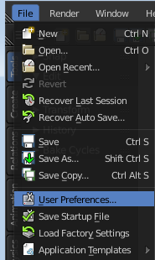
The user preferences is the place where you can tweak several settings to your needs. It can be opened in the File menu.

The User Preferences contains several tabs. And every tab contains several rows or panels with content. We will go through them one by one.

When you have changed something, and want that changes to be permanent, then you are required to save the user settings. See the Save User Settings button in the header.

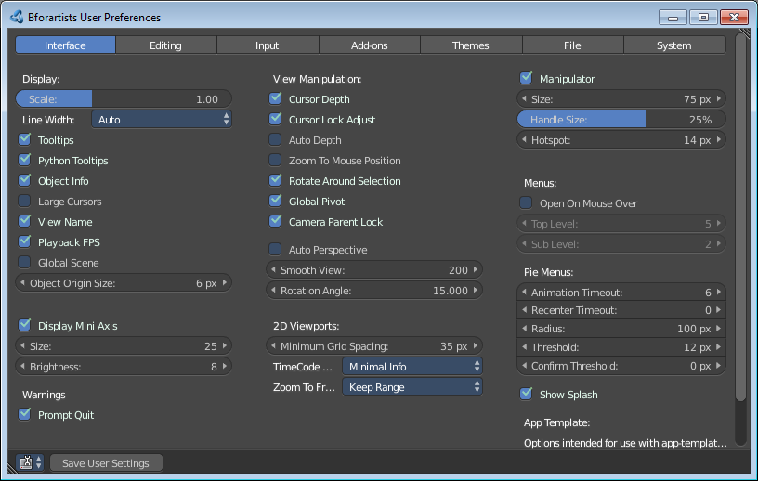
Note
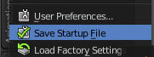
Not everything can be changed from the User Preferences. Everything regarding Layout is stored in the startup file, and not in the User Preferences. So when you want to save a layout change then you have to save the startup file. The menu item is right below the User Preferences button.

Interface Tab
The Interface category contains settings to change how UI elements are displayed and how they react.

Header

Editor Type Menu
Here you can switch to another editor type.

Save User Settings
Save the user settings.

First Row
Ther first row contains some Display related settings.

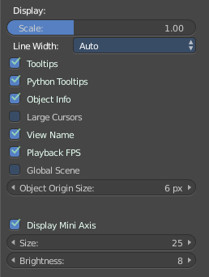
Display
The Display section contains settings around the UI display.

Scale Edit Box
At 4K displays the whole UI elements are usually ways too small. Here you can scale the whole UI size display by moving the slider to the needed value.

Tooltips
Display tooltips in the UI. With this feature unticked you won't see any tooltips anymore. It is not recommended to turn this feature off. The icon buttons needs the tooltips to display the tool name.

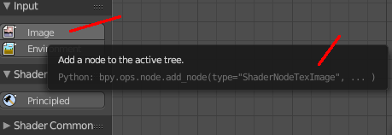
Python Tooltips
Every tooltip can also display the Python code tag for the tool. It may look like noise in the first moment. But can give you some further hints here and there. Some tooltips, like the Node editor buttons, doesn't have a proper tool description by design. Here the Python tooltip can tell you the function when you turn it into pure icon buttons.
It is not recommended to turn the Python tooltips off.

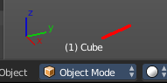
Object Info
Display Object name and Frame number in the lower left edge of the 3D view

Large Cursors
Use large mouse cursors if available.

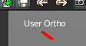
View Name
Display the name of the current view up left in the 3D view.

Playback FPS
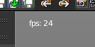
Show the frames per second screen refresh rate while an animation is played back. It appears in the viewport corner, displaying red if the frame rate set cannot be reached. Amd replaces the View name while the animation is playing.

Global Scene
Forces the current scene to be displayed in all screens (a project can consist of more than one scene).

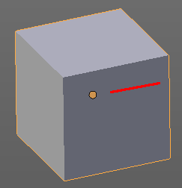
Object Origin Size
Here you can adjust the size of the Object origin, which is displayed as an orange dot at the place where the Object origin is.
The size can be set between 4 and 10 pixels.

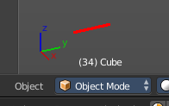
Display Mini Axis
Display the mini axis widget down left

Size
Here you can define the size of the Mini Axis. The size can be set between 10 and 64 pixels

Brightness
Here you can set the transparency of the Mini axis. The range goes from 0 to 10. 10 is full opaque. 0 is around 50% semi transparent.

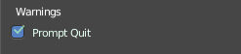
Warnings
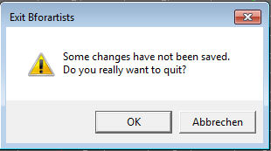
This section has just one entry.

Prompt Quit
When you close Bforartists then you can display a do you really want to quit warning.

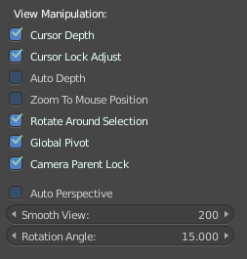
Second Row

View Manipulation
This section contains settings around things like mouse cursor and pivot.

Cursor Depth
Use the depth under the mouse when placing the 3D cursor. That way you can place the 3D cursor at the surface of an object.

Auto Depth
Use the depth under the mouse to improve view pan, rotate, zoom functionality.

Zoom to Mouse Position
When enabled, the mouse pointer position becomes the focus point of zooming instead of the 2D window center.

Rotate Around Selection
The selected object becomes the rotation center of the viewport. When there is no selection the point of the last selection will be used.
Hint
This may seem ideal behavior, however, it can become problematic with larger objects such as a terrain-mesh, where the center is not necessarily your point of interest.

Global Pivot
Lock the same rotation/scaling pivot in all 3D Views.

Camera Parent Lock
When the camera is locked to the view and in fly mode, transform the parent rather than the camera.

Auto Perspective
With Auto perspective off when you switch to one of the side views the chosen orthographic or perspectivic view is kept. Means when you have the distorted perspectivic view, and switch to top view, then your mesh will be perspectivic distorted here too.
With Auto Perspective the view in the side views will be orthographic, and not perspectivic, no matter what View Persp/Ortho is chosen.

Smooth View
The switch to change to another view is animated. Here you can adjust the length of time the animation takes when changing the view with the numpad (Top/Side/Front/Camera...). A value of zero will remove the animation, and immediately switch to the chosen view.

Rotation Angle
Rotation step size in degrees, when Numpad4, Numpad6, Numpad8, or Numpad2 are used to rotate the 3D View.

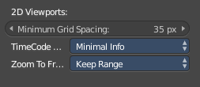
2D Viewports
Settings for 2D viewports like Timeline, Dopesheet, Graph or NLE Editor.

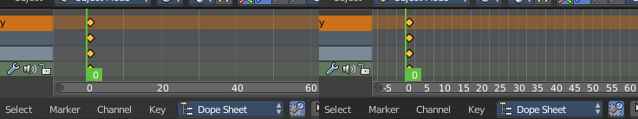
Minimum Grid Spacing
Here you can adjust the minimum number of pixels between grid lines in a 2D viewport. This affects for example Timeline, Dopesheet, Graph or NLE Editor.

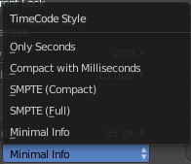
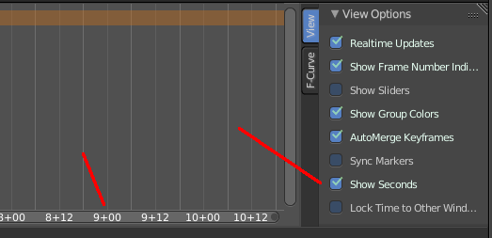
TimeCode Style
In Timeline, Dopesheet, Graph and NLE editor you can either display the keyframe number or the time in the timeline. Here you can define how the time gets displayed when you have chosen to display time.

Zoom To Frame Type
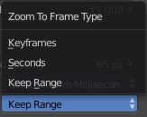
Timeline, Dopesheet, Graph and NLE. Here you can define how zooming to frame focuses around current frame.

Third Row

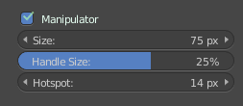
Manipulator
Turns the 3D widget on and off. Note that you can still turn the 3D widget on and off in the 3D view. So this checkbox is a bit useless.

Size
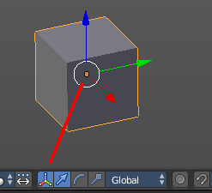
Here you can change the size of the 3D widget.

Handle Size
Here you can change the handle size of the 3D widget. The area that you can grab.

Hotspot
Here you can change the hotspot size of the 3D widget. The center of the widget.

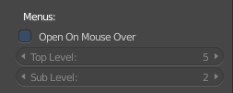
Menus
Menus section contains some menu relatet settings.

Open on Mouse Over
With this ticked you don't need to click at a menu item to open it.

Top Level
Time delay in 1/10 second before a menu opens (Open on Mouse Over needs to be enabled).

Sub Level
Same as above for sub menus (for example: File ‣ Open Recent).

Pie Menus
Bforartists has some pie menus onboard. Here you can adjust some settings for it.

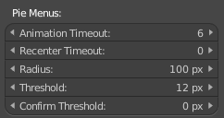
Animation Timeout
Length of animation when opening Pie Menus.

Recenter Timeout
The window system tries to keep the pie menu within the window borders. Pie menus will use the initial mouse position as center for this amount of time, measured in 1/100ths of a second. This allows for fast dragged selections.

Radius
The size of the Pie Menu.

Threshold
The distance from center before a selection can be made.

Confirm Threshold
Distance threshold after which selection is made (zero disables).

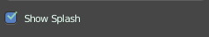
Show Splash
Display the Splash Screen when starting Bforartists.

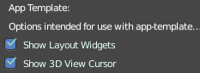
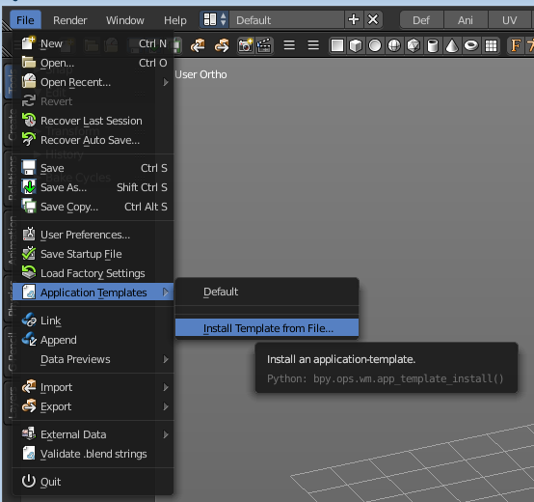
App Template
App Templates section contains some settings for the Application template system. You need to create and use such a template to see the needed effect.

Show Layout Widgets
Show Screen Layout Editing UI.

Show 3D cursor
Show the 3D View Cursor.

Editing

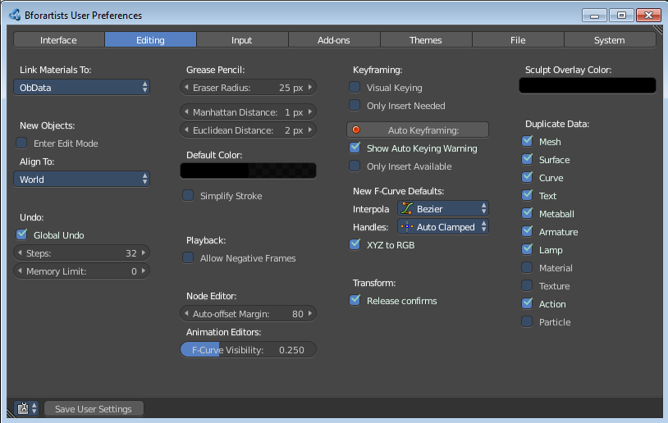
These preferences control how several tools will interact with your input.

Header

Editor Type Menu
Here you can switch to another editor type.

Save User Settings
Save the user settings.

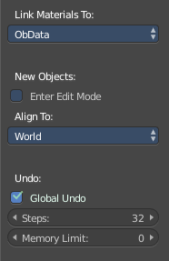
First row

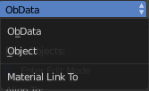
Link Materials To
Here you can define how materials will be linked to its objects. Almost everything in Bforartists is organized in a hierarchy of data-blocks. A data-block can be thought of as containers for certain pieces of information. For example, the Object data-block contains information about the Object’s location while the Object Data ObData data-block contains information about the mesh.

ObData
Any created material will be created as part of the ObData data-block.

Object
Any created material will be created as part of the Object data-block.

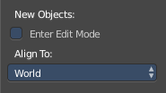
New objects

Enter Edit Mode
If selected, Edit Mode is automatically activated when you create a new object.

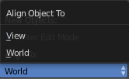
Align To

World
New objects align with world coordinates.

View
New object align with view coordinates.

Undo

Global Undo
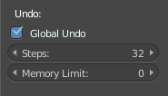
Bforartists Undo system is split in several subparts. Global undo stores the undo step outside of Edit mode.For example for duplicating Objects, changing panel settings or switching between modes.
Warning
It is not recomended to turn it off! Disabling this option does save memory. But it stops the redo panel from functioning, also preventing tool options from being changed in some cases.

Steps
Number of Undo steps available.

Memory Limit
Maximum memory usage in Mb (0 is unlimited).

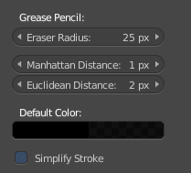
Grease Pencil
Here you can find some options for Grease Pencil

Eraser Radius
The size of the eraser used with the grease pencil. This setting can also be found in the tool shelf

Manhattan Distance
The minimum number of pixels the mouse has to move horizontally or vertically before the movement is recorded.

Euclidian Distance
The minimum distance that mouse has to travel before movement is recorded.

Default Color
The default color with which you draw a stroke.

Simplify Stroke
Simplifys the pencil stroke after it is finished.

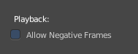
Playback

Allow Negative Frame
The time Cursor can be set to negative frames with mouse or keyboard. But usually it doesn't play it then. When using Use Preview Range, this also allows playback of frames in negative range.

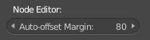
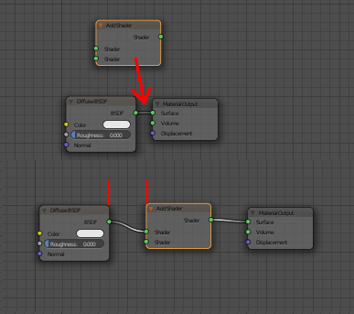
Node Editor

Auto Offset Margin
When you insert a new node between two existing connected nodes, then the two nodes gets pushed to left and right, with an offset. Here you can adjust this offset.

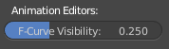
Animation Editors

F-Curve Visibility
The amount with which unselected FCurves in the Graph Editor are semitransparent.

Row Three

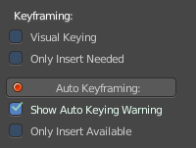
Keyframing
In many situations, animation is controlled by keyframes. The state of a value (e.g. location) is recorded in a keyframe and the animation between two keyframes is interpolated by Blender.

Visual Keying
When an object is using constraints, the objects property value doesnt actually change. Visual Keying will add keyframes to the object property, with a value based on the visual transformation from the constraint.

Only Insert Needed
This will only insert keyframes if the value of the propery is different.

Auto Keyframing
Enables Auto Keyframe by default for new scenes.

Show Auto Keying Warning
Displays a warning at the top right of the 3D View, when moving objects, if Auto Keyframe is on.

Only Insert Available
This will only add keyframes to channel F-Curves that already exist.

New F-Curve Defaults

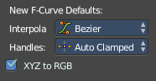
Interpolation
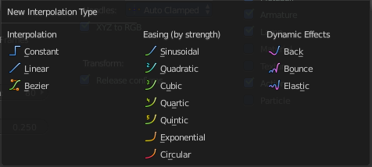
This controls how the state between two keyframes is computed. Default interpolation for new keyframes is Bézier which provides smooth acceleration and de-acceleration whereas Linear or Constant is more abrupt.

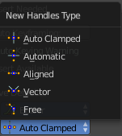
Handles
The default handle types for F-Curves.

XYZ to RGB
Color for X, Y or Z animation curves (location, scale or rotation) are the same as the color for the X, Y and Z axis.

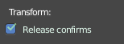
Transform

Release confirm
Dragging LMB on an object will move it. When you release the mouse, then the object "drops" from the mouse. Wiht this option unticked, a mouse click is necessary to drop the currently attached object.

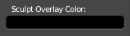
Fourth Row

Sculpt Overlay Color
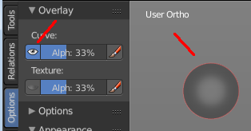
This color button allows the user to define a color to be used in the inner part of the brushes circle when in sculpt mode, and it is placed as an overlay to the brush, representing the focal point of the brush influence.
The overlay color is visible only when the overlay visibility is selected (clicking at the eye to set its visibility), and the transparency of the overlay is controlled by the alpha slider located at the brush pop-up, located at the top of the tool shelf, when in sculpt mode.

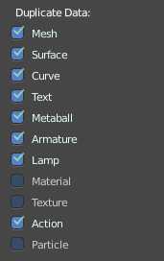
Duplicate Data
When you duplicate an object, then some of the containing data of it gets also duplicated. But not everything. Some data, like a material, remains linked with the original object . Here you can define what data gets duplicated for the new object too.

Input

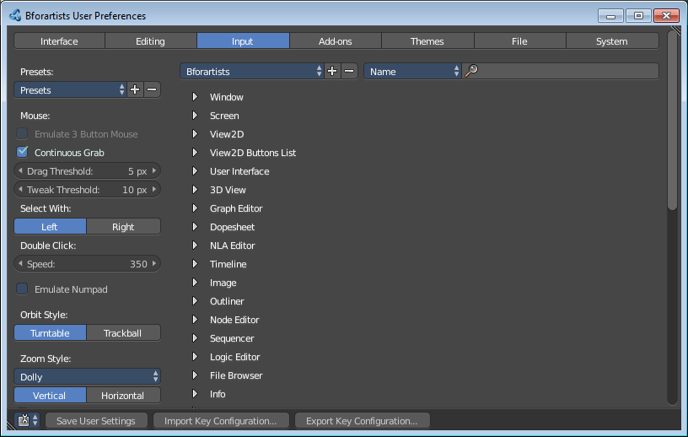
Here you can customize how Blender reacts to mouse and keyboard, and change keymap entries.
In the left row you will find some general mouse related settings. Like with what mouse button to select, or the orbit style. The right row is the actual keymap. Here is all input defined. Not just tools. This also includes the mouse action to split windows for example.

Header

Editor Type Menu
Here you can switch to another editor type.

Save User Settings
Save the user settings.

Import Key Configuration
Import a key configuration python file into Bforartists.

Export Key Configuration
Export a key configuration python file from Bforartists.

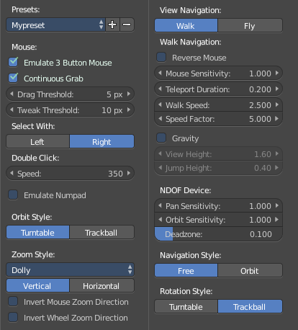
Left row
In the left row you can find some general mouse related settings.

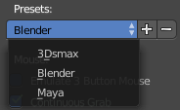
Presets
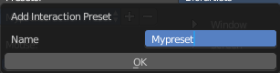
A dropdown box where you can choose some presets for the left row, the general mouse related settings.
You can also ceate your own presets here by clicking at the + button, or delete a preset with the - button.
The created preset will be stored immediately by clicking at OK. You don't need to save the user preferences to store the new preset. But you need to save the user preferences to set this new preset as the permanent active one.

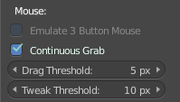
Mouse

Emulate 3 Button Mouse
In the Windows world 3 button mouses are common. But Apple for example has a single mouse button. Bforartists can emulate a 3 button mouse. The third mouse button will then be emulated by a key combination.
3-button Mouse | 2-button Mouse | Apple Mouse
LMB | LMB | LMB (mouse button)
MMB | Alt-LMB | Alt-LMB (Option/Alt key + mouse button)
RMB | RMB | Cmd-LMB (Command/Apple key + mouse button)

Mouse/Keyboard combinations referenced in this manual can be expressed with the combinations shown in the table. For example, MMB drag becomes Alt-LMB drag. Shift-Alt-RMB becomes Shift-Alt-Cmd-LMB on a single-button mouse.

Hint
The Mouse emulate option is only available if Select With is set to Right. It does not work with Left Click select.

Continuous Grab
When you work for example with a manipulator, then it can happen that you move your mouse out of the current editor. Normally the action that you want to perform then stops, since the mouse is not longer in the editor window where it belongs. Continuous grab fixes this problem by warping the mouse pointer within the current view.
Note
Cursor warping is only supported by relative input devices (mouse, trackball, trackpad).
Graphics tablets, however, typically use absolute positioning, this feature is disabled when a tablet is being used.
This is detected for each action, so the presence of a tablet will not disable Continuous Grab for mouse cursor input.

Drag Threshold
The number of pixels that a User Interface element has to be moved before it is recognized by Blender.

Tweak Threshold
Number of pixels that you have to drag before a tweak event gets triggered.

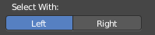
Select with
You can choose which button is used for selection (the other one is used to place the 3D cursor).

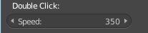
Double Click
Here you can adjust the time after which two mouse clicks behind are recognized as a double click.

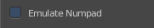
Emulate Numpad
Laptops usually doesn't have Numpad keys. Here you can choose to use the number keys above the letters as numpad keys.

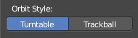
Orbit Style
Here you can ajdust in what style you rotate the 3D View. Turntable and Trackball navigation reacts a bit different. Turntable navigation tries to hold the horizon line while rotation. Turntable rotation rotates also the horizon line.

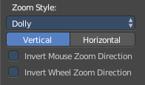
Zoom Style

Zoom Style Dropdown Box
In the dropdown box you can adjust the zoom style.

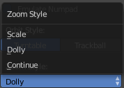
Scale
Scale zooming depends on where you first click in the view.

Dolly
Dolly zooming works similarly to Continue zooming except that zoom speed is constant.

Continue
The Continue zooming option allows you to control the speed (and not the value) of zooming by moving away from the initial click point. Moving up from the initial click-point or to the right will zoom out, moving down or to the left will zoom in. The further away you move, the faster the zoom movement will be.

Vertical / Horizontal
With Vertical moving up zooms out and moving down zooms in. With Horizontal moving left zooms in and moving right zooms out.

Invert Mouse Zoom Direction
Inverts the Zoom direction for Dolly and Continue zooming.

Invert Wheel Zoom Direction
Inverts the direction of the mouse wheel zoom.

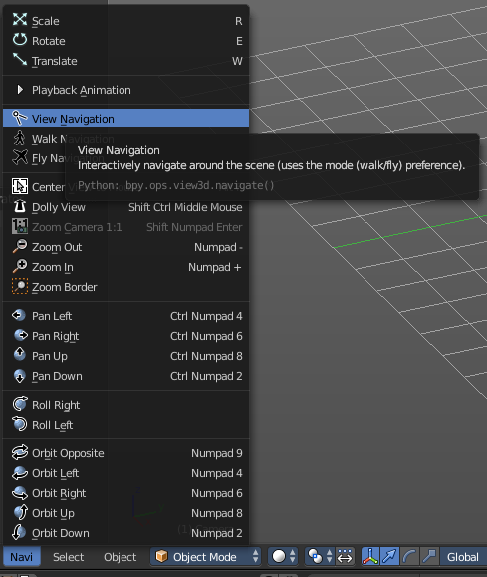
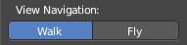
View Navigation
Here you can adjust how the View navigation in the 3D view behaves. You can choose between walk and fly.

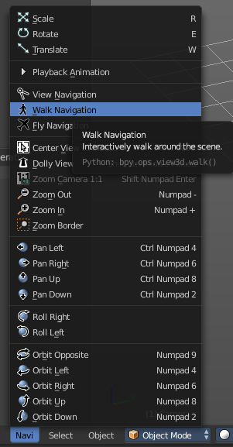
Walk Navigation
Here you can adjust how the Walk navigation in the 3D view behaves. Note that these settings also influences the View navigation in Walk navigation style.

Reverse Mouse
Reverse the mouse movement when you move upwards or downwards

Mouse Sensitivity
Here you can adjust how strong the viewport movement reacts to the mouse movement

Teleport Duration
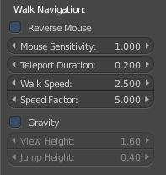
Here you can adjust the teleport duration when teleporting in navigation mode.

Walk Speed
Here you can adjust the walk speed

Speed Factor
Here you can adjust the run speed.

Gravity
Here you can choose if the virtual character, your point of view, uses gravity.

View Height
Here you can adjust the height of the point of view for your virtual character. This setting requires to have Gravity on.

Jump Height
Here you can adjust the maximal jump height for your virtual character. This setting requires to have Gravity on.

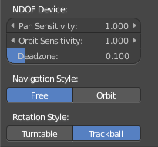
NDOF device
Here you can adjust some settings for a 3D mouse.

Pan Sensitivity
Here you can adjust the pan sensitivity.

Orbit Sensitivity
Here you can adjust the orbit sensitivity

Deadzone
The initial movement that is needed before the movement gets recognized.

Navigation Style
Here you can choose the navigation style between Free and Orbit

Rotation Style
Here you can ajdust in what style you rotate the 3D View. Turntable and Trackball navigation reacts a bit different. Turntable navigation tries to hold the horizon line while rotation. Turntable rotation rotates also the horizon line.

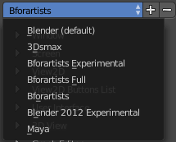
Right row

Keyconfig dropdown box
Bforartists comes with several predefined key configurations. Here you can choose between them. You need to save the User Settings to make the change permanent.
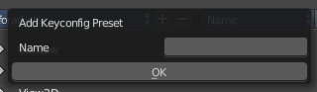
To add your own keymap, first change the keymap to your needs. Then click the + button. This will call a form where you can give your keymap a name. Click OK to store it. The process to create a new keymap does not require to save the user settings. To have this keymap active after the next restart does.

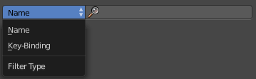
Search field
You can search the keymaps for keys and terms. In the left edit box you can adjust if you want to search for names and terms, or for keystrokes.

Keymap Editor
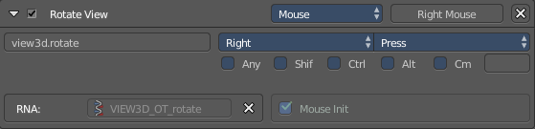
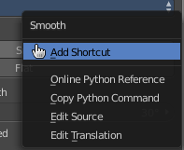
The Keymap editor is the list where the single inputs are defined. Every input can have several specific operator settings in the lower area. The upper area defines the general things like the key combos. The lower area those operator specific settings.
Normally you don't edit those key entries manually. Most of the usual tools have an entry in the right click menu to create or to change the hotkey. But sometimes you have to do this task manually.

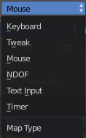
Map Type
Here you define what input will control the function.

Type of Event
Here you define your main hotkey. In our case the right mouse.

Operator
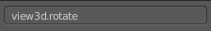
Here you can find the Python operator name for the tool.

Type of Event
The main hotkey again. For special events like mouse events you have a dropdown box here.

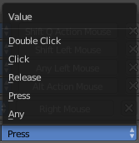
Value
What key action is required. On click, on double click, etc. ...

Secondary hotkeys
Many hotkeys uses a key combination, for example Shift D for select. Here you can define those secondary hotkeys.

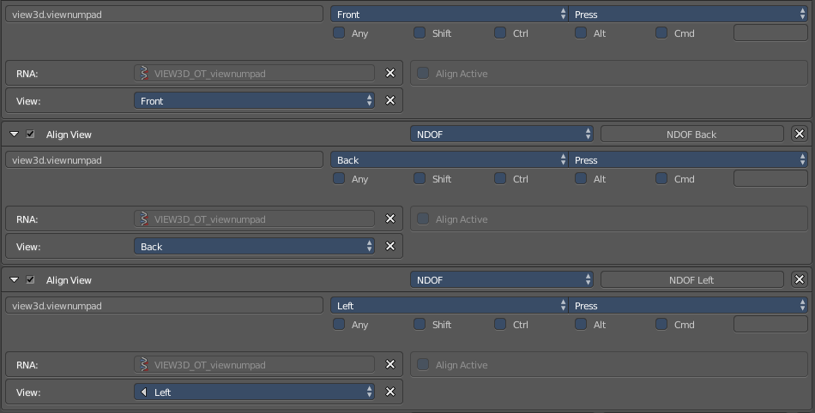
Specific settings
Every operator can have several settings. And some tools even just defines itself by those different settings. Align view for example has the same operator called view3d.viewnumpad. But switches to the needed view by the right entry in the specific settings then.
What is equal in the key map in all cases is the RNA entry. That's the name of the operator again. But this time not the Python operator name. But the C operator name.

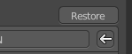
Restore
When you modify a keymap item, then you will see a Restore button appear at the right side. This indicates that this keymap item gots modified. A click at the Restore button will restore the original hotkey.

Add-ons
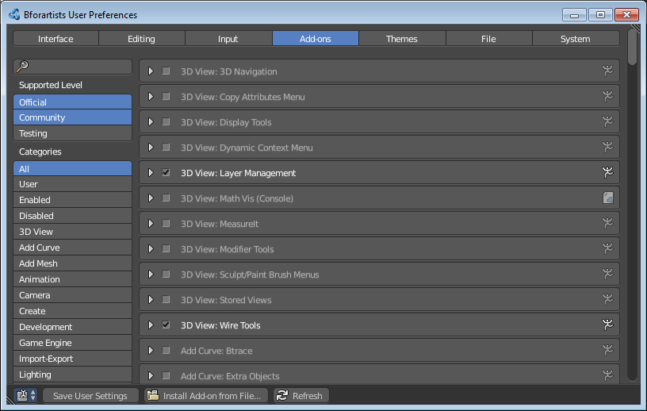
An add-on is external software written by other developers. Add-ons are a way to extend the core functionality of Bforartists. Bforartists already comes with lots of add-ons. Some already activated. Here you can manage them, and add even more add-ons if required.
Note that Bforartists works with Blender addons.
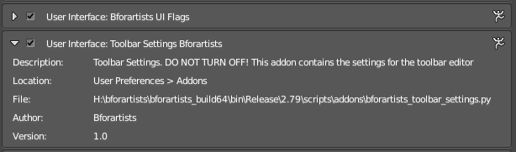
Note also that this list contains some add-ons that are required by Bforartists to work proper. You will see a warning in those addons. Don't turn them off. Or vital parts of Bforartists will not longer work. Like the toolbar.

Header

Editor Type Menu
Here you can switch to another editor type.

Save User Settings
When you have enabled or disabled an addon, then you should save the user settings to make the change permanent.

Install Add-on
Here you can install external add-ons. Note that addons that comes as a zip file should be loaded zipped. And not unzipped.

Refresh
Scan the add-on directories for new modules. This is useful when you decide to install an add-on manually.

Left Row

Search field
Here you can search for a specific addon

Supported Level
Here you can filter the addons by supported level.
The addons comes in three flavours. The official addons are the addons from the Blender developers. Community are the addons from Community developers that doesn't officially belong to the Blender developer team. And Testing add-ons are add-ons that aren't really finished yet. They can do the job, but are experimental.

Categories
Here you can filter the addons by categories.
The addons comes in different categories, dependant of their useage.

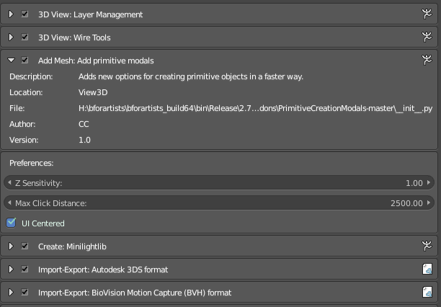
Right row
This is the list of add-ons. To enable an add-on, tick the checkbox at the left. When you expand an add-on then you will find some further informations. Sometimes you will also find some more settings.

Themes

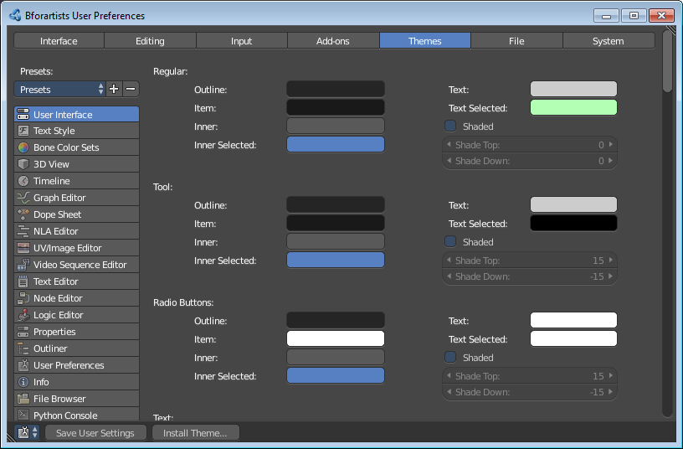
The Themes tab allows you to customize interface appearance and colors.
The colors for each editor can be set separately. Simply select the editor you wish to change in the multi-choice list at the left, and adjust colors as required. Notice that changes appear in real-time on your screen. In addition, details such as the dot size in the 3D View or the Graph Editor can also be changed.

Header

Editor Type Menu
Here you can switch to another editor type.

Save User Settings
Save the user settings.

Install Theme
Here you can install a new theme.

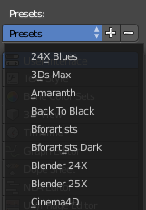
Presets
Bforartists comes with several theme presets. You can choose between them in the dropdown box. Don't forget to save the user settings to make the change permanent.
To create a new theme, click the + button next to the preset selection drop-down and enter a name. This will save the theme to an XML file in the ./scripts/presets/interface_theme/ subdirectory of one of the configuration directories.
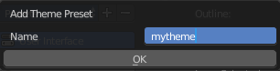
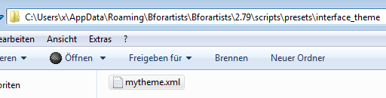
To share the new created theme you have to copy it from that folder. This xml file can then be loaded as a theme at another computer with Bforartists installed.

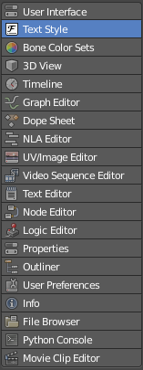
Editors
The list of the editors that you can theme. Every editor can have its own theming.

Theming settings
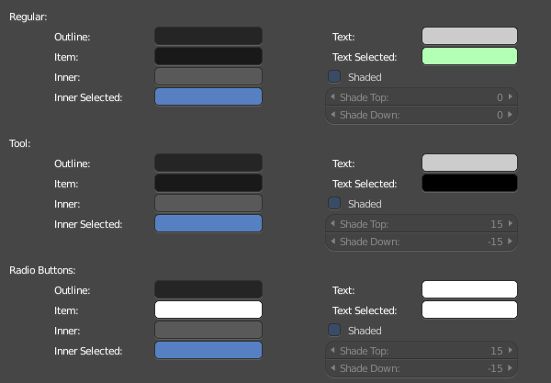
Here you can adjust the colors for the single UI elements.

File Preferences
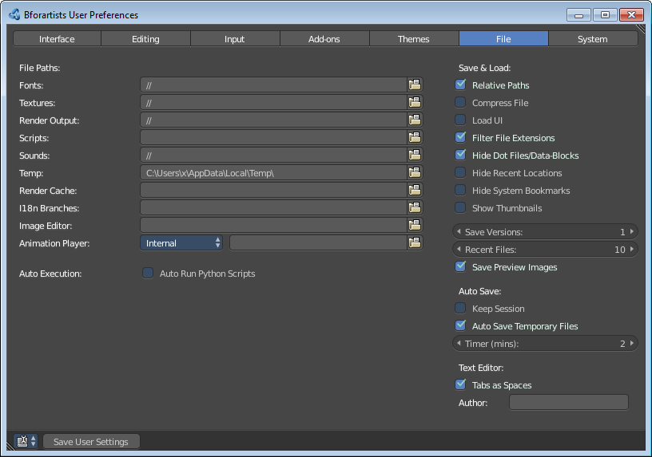
The File Preferences tab allows you to configure auto-save preferences and set default file paths for blend-files, rendered images, and more.

Header

Editor Type Menu
Here you can switch to another editor type.

Save User Settings
Save the user settings.

File Paths
Locations for various external files can be set for the following options:

Fonts
Default location when searching for font files.

Textures
Default location when searching for image textures.

Render Output
Where rendered images/videos are saved.

Scripts
An additional location to search for Python scripts.
By default Bforartists looks in several directories (OS dependant) for scripts. By setting a user script path in the preferences an additional directory is looked in. This can be used to store certain scripts/templates/presets independently of the currently used Blender Version.
Inside the specified folder specific folders have to be created to tell Bforartists what to look for where. This folder structure has to mirror the structure of the scripts folder found in the installation directory of :
- scripts
- add-ons
- modules
- presets
- camera
- cloth
- interface_theme
- operator
- render
- ...
- startup
- templates
Not all of the folders have to be present.
Python scripts (including driver expressions) are not executed by default for security reasons.

Sounds
Default location when searching for sound files.

Temp
The location where temporary files are stored.

Render Cache
The location where cached render images are stored.

I18n Branches
The path to the /branches directory of your local svn-translation copy, to allow translating from the UI.

Image Editor
The path to an external program to use for image editing.

Animation Player
By default Bforartists uses the internal player to play back animations. Here you can choose an external program to use for playback of rendered animations. There are also some presets available.

Hint
If these defined folders do not exist, they will not be created automatically.

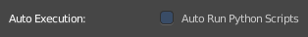
Auto Execution

Auto Run Python Scripts
You may choose to ignore the security issues, and allow scripts to be executed automatically.

Save & Load

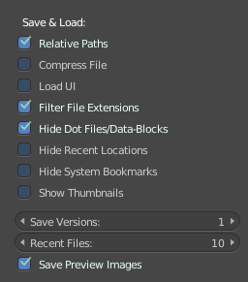
Relative Paths
By default, external files use a relative path.

Compress File
Compress blend-file when saving.
The option to Compress files will compact your files whenever Blender is saving them. Dense meshes, large packed textures or lots of elements in your scene will result in a large blend being created.
This option may slow down Blender when you quit, or under normal operation when Blender is saving your backup files. Using this option traces processor time for file-size.

Load UI
In Bforartists you can load the scene in the screen layout in which you have saved it. Default is off.
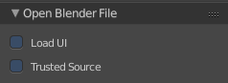
This can also be changed individually when loading a file from the Open blend-file panel of the File Browser.

Filter File Extensions
By activating this, the file dialog in the File Browser will only show appropriate files in the Load dialog. Blend files for example.
The selection of file types can also be changed in the header of the file dialog.

Hide Dot File/Data-blocks
On non Windows systems like Linux and Mac OS X files are hidden by a dot in front of the file name. Here you can make them visible in the file browser if you want. Note that this feature does not work with Windows

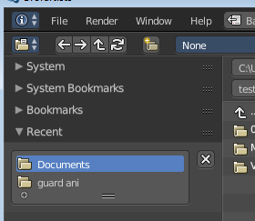
Hide Recent Locations
Hides the Recent panel of the File Browser which displays recently accessed folders.

Hide System Bookmarks
Hides the System Bookmarks panel of the File Browser which displays the system bookmarks.

Show Thumbnails
Displays a thumbnail of images and movies when using the File Browser.

Save Versions
Number of versions created for the same file (for backup).
This option tells Bforartists to keep the indicated number of saved versions of your file in your current working directory when you manually save a file. These files will have the extension: .blend1, .blend2, etc., with the number increasing to the number of versions you specify. Older files will be named with a higher number. e.g. With the default setting of 2, you will have three versions of your file: *.blend (your last save), *.blend1 (your second last save) and *.blend2 (your third last save).

Recent Files
The number of recent files to display in the Recent panel.

Save Preview Images
When this option is off, previews of images and materials in the File Browser are created on demand. With this option on it will save these preview images into your blend-file. This will increase the size of your blend file by the size of the thumbnails.

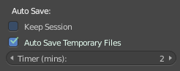
Auto Save

Keep Session
Always load session recovery files and save it after quitting Bforartists. This means you can work at a blend file, quit Bforartists, and when you reopen it, then it will load with this blend file in the latest state.

Auto Save Temporary File
Enable Auto Save. Auto save creates a temporary file.
Checking this box tells Blender to automatically save a backup copy of your work-in-progress to the Temp directory (refer to the File tab in the User Preferences for its location).
The Auto Saved files are named using a random number and have a blend extension.

Timer
Here you can asjust the number of minutes between each Auto Save. The minimum is 1, and the Maximum is 60 (Save at every one hour).

System Preferences

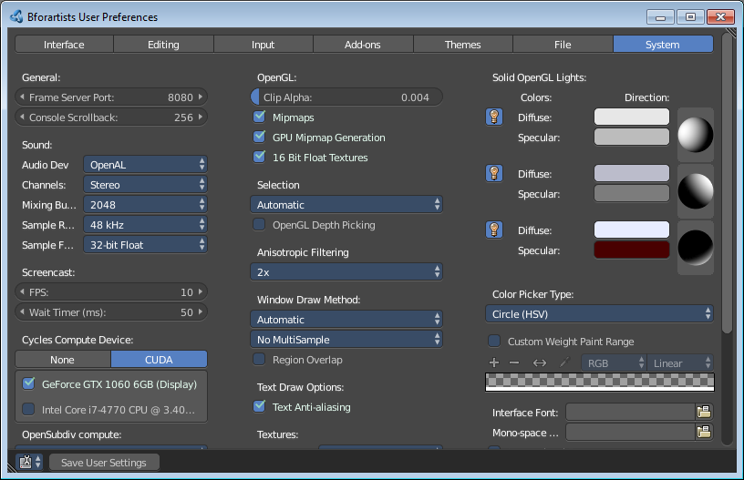
The System tab contains system related settings. Such as Audio settings, Cuda device, OpenGL Color settings and so on.

Header

Editor Type Menu
Here you can switch to another editor type.

General

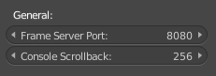
Frame Server Port
TCP/IP port used in conjunction with the IP Address of the machine for frameserver rendering. Used when working with distributed rendering. Avoid changing this port value unless it is conflicting with already existing service ports used by your Operating System and/or softwares. Always consult your operating system documentation and services or consult your system administrator before changing this value.

Console Scrollback
The number of lines, buffered in memory of the console window. Useful for debugging purposes and command line rendering.

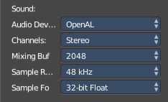
Sound

Audio Device
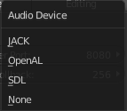
Here you can set the audio device.

None
No Audio support. No audio output, but audio strips can be loaded normally.

SDL
Uses Simple Direct Media Layer API from libsdl.org to render sounds directly to the sound device output.

OpenAL
Provides buffered sound rendering with 3D/spatial support. Used for 3D source support by Speaker Objects and the Game Engine.

Jack
The Jack Audio Connection Kit

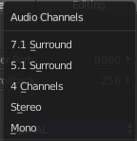
Channels
Set the audio channel count. Available options are: Stereo, 4 Channels , 5.1 Surround , 7.1 Surround

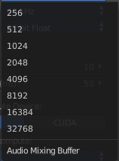
Mixing Buffer
Set the number of samples used by the audio mixing buffer. Available options are: 512 , 1024 , 2048, 4096 , 8192, 16384, and 32768

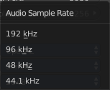
Sample Rate
Set the audio sample rate. Available options are: 44.1 Khz, 48 Khs, 96 Khz and 192Khz

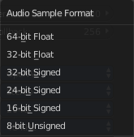
Sample Format
Set the audio sample format. Available options are: 32 bit float, 8 bit Unsigned, 16 Bits Signed, 24 Bits Signed, 32 Bits Signed, 32 Bits Float, and 64 Bits Float.

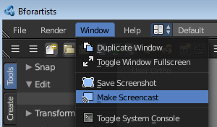
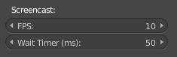
Screencast
These settings are used to control the frame-rate for recording a Screencast.

FPS
Frame-rate for screencast playback.

Wait Timer
Time in milliseconds between each frame recorded for screencast.

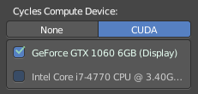
Compute Device
The Options here will set the compute device used by the Cycles render engine.

None
When set to None or the only option is None: your CPU will be used as a computing device for Cycles Render Engine.

CUDA
If the system has a compatible Nvidia CUDA enabled graphics card you will be able to use it to render with the Cycles render engine.

OpenCL
If the system has a compatible OpenCL device, it will show up has an option for rendering cycles. Note that OpenCL currently has limited support, see: Cycles Features page for more information.

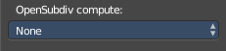
OpenSubdiv Compute
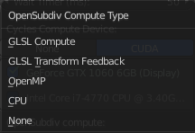
The Options here will set the compute device used by OpenSubdiv for the Subdivision Surface Modifier.

None
Disables any OpenSubdiv compute devices, makes sure legacy subsurf method is used. Use this option when OpenSubdiv causes any bugs or regressions.

CPU
Single threaded CPU implementation. It is mainly useful in cases when GPU compute is possible and threaded CPU option causes artifacts (it is unlikely to happen, but still possible).

OpenMP
Multi-threaded CPU implementation. Use it for maximum performance in cases when GPU compute is not available.

GLSL Transform Feedback
Uses GPU to perform calculations, has minimal requirements to video card and driver.

GLSL Compute
Uses GPU to perform calculations, supposed to be more efficient than Transform Feedback but also has higher requirements to video card and driver.

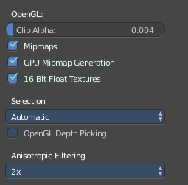
OpenGL
Here you can find some OpenGL settings.

Clip Alpha
Clip alpha below this threshold in the 3D View. Note that the default is set to a low value to prevent issues on some GPU’s.

Mipmaps
Scale textures for 3D View using Mipmap filtering. This increases display quality, but uses more memory.

GPU MipMap Generation
Generate MipMaps on the GPU. Offloads the CPU Mimpap generation to the GPU.

16 Bit Float Textures
Enables the use of 16 Bit per component Texture Images (Floating point Images).

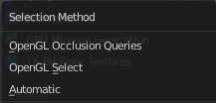
Selection
Selection method to use for selecting.

Automatic
Automatically choses the best setting depending on your OS, GPU, and drivers.

OpenGL Select
Legacy OpenGL selection method for legacy hardware.

OpenGL Occlusion Queries
More optimized OpenGL selection method. Use this method if you are using an OpenSubdiv Compute compute device.

OpenGL Depth Picking
Use the depth buffer for picking 3D View selection.

Anisotropic Filtering
Sets the level of anisotropic filtering. This improves the quality of how textures are drawn at the cost of performance. Available Options are: Off (No Filtering), 2x, 4x, 8x, and 16x.

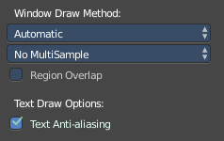
Window Draw Method
Some Window draw method related settings.

Window Draw Method
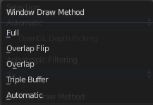
Specifies the Window Draw Method used to display Blender Window(s).

Automatic
Automatically set based on graphics card and driver.

Triple Buffer
Use a third buffer for minimal redraws at the cost of more memory. If you have a capable GPU, this is the best and faster method of redraw.

Overlap
Redraw all overlapping regions. Minimal memory usage, but more redraws. Recommended for some graphics cards and drivers combinations.

Overlap Flip
Redraw all overlapping regions. Minimal memory usage, but more redraws (for graphics drivers that do flipping). Recommended for some graphic cards and drivers combinations.

Full
Do a full redraw each time. Only use for reference, or when all else fails. Useful for certain cards with bad to no OpenGL acceleration at all.

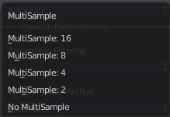
Multi-Sampling
This enables FSAA for smoother drawing, at the expense of some performance.

Note
Multisampling is known to cause selection issues on some configurations.

Region Overlap
This checkbox will enable Blender to draw regions overlapping the 3D View. It means that the Object Tools and Transform Properties regions, which are opened by using the shortcuts T and N will be drawn overlapping the 3D View editor.
If you have a capable graphics card and drivers with Triple Buffer support, clicking the checkbox will enable the overlapping regions to be drawn using the Triple Buffer method, which will also enable them to be drawn using Alpha, showing the 3D View contents trough the Object Tools and Transform Properties regions.

Text Draw Options

Text Anti-aliasing
Enable interface text anti-aliasing. When disabled, texts are drawn using text straight render (Filling only absolute Pixels).

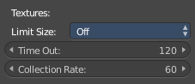
Textures

Limit Size
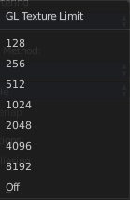
Limit the maximum resolution for pictures used in textured display to save memory. The limit options are specified in a square of pixels, (e.g.: the option 256 means a texture of 256×256 pixels) This is useful for game engineers, whereas the texture limit matches paging blocks of the textures in the target graphic card memory. Available Options are: Off (No limit), 128, 256, 512, 1024, 2048, 4096, and 8192.

Time Out
Time since last access of a GL texture in seconds, after which it is freed. Set to 0 to keep textures allocated. Minimum: 0, Maximum: 3600.

Collection Rate
Number of seconds between each run of the GL texture garbage collector. Minimum: 0, Maximum: 3600.

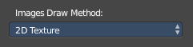
Image Draw Method
Method to draw images as the following options are supported:

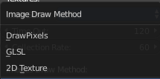
2D Texture
Uses CPU for display transform and draws images as a 2D texture.

GLSL
Fastest method using GLSL for display transform and draws images as a 2D texture.

Draw Pixels
Uses CPU for display transform and draws images as a 2D texture.

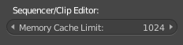
Sequencer/Clip Editor

Memory Cache Limit
Upper limit of the sequencer’s memory cache (megabytes). For optimum clip editor and sequencer performance, high values are recommended.

Solid OpenGL lights
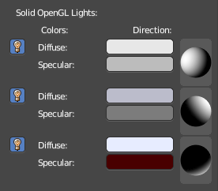
The 3D view uses Solid OpenGL lamps to light the 3D view. You can enable three different light sources here. These lamps does not affect the rendering. Their only purpose is to light the 3D view.
You can turn on or off the lamps with the lamp icons in front . There should be at least one light enabled.
Diffuse color is the constant color of the lamp.
Specular is the hilight color of the lamp.
The icon at the end allows you to control the direction of the light source.

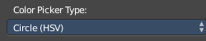
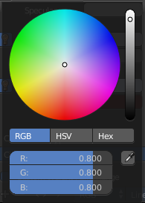
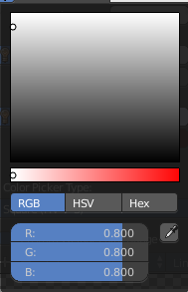
Color Picker Type
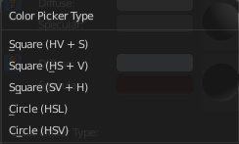
Here you can choose the type of Color picker that will show when you click on a color field. You can choose between three square types and two circle types.

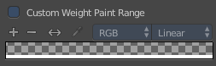
Custom Weight Paint Range
How much a bone deforms is defined by Mesh Skin weighting. For visualization and weightpainting a color ramp is used. Which goes from blue to green to red. Blue is the lowest weighting, red the hightest.
Here you can define a custom color ramp with your own colors for weightpainting.

Custom Weight Paint Range
The checkbox to enable or disable the custom weight paint range.

Gradient Colors dialog
The + Button adds a color ramp point. That way you can have more than one color in the gradient.
The - Button removes the currently selected color ramp point.
The <> Element flips the color ramp
The Color picker button? I have no idea! It is not documented, and not to figure out.
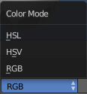
Color Mode is a dropdown box where you can choose the color mode for the gradient.

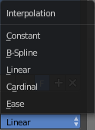
Interpolation is a dropdown box where you can choose the interpolation mode for the gradient.

In the Color Ramp element you will see the color ramp with the single color points.
Choose Active Color Stop is the stop point of the gradient.
Position is a edit box where you can fine tune the position of the currently selected color point

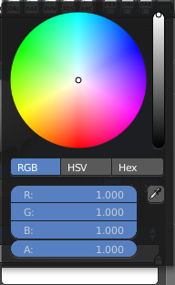
Set Color of selected color stop is the color of the currently selected color point. When you click at it then you will get a color dialog that allows you to setup the color.

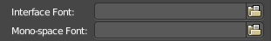
Interface Font
Here you can define a custom interface font. The font in the whole UI.

Monospace Font
Here you can define a custom Monospace font. That's the one used in the python console for example.

Internationalization
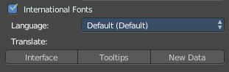
Bforartists supports a wide range of languages. Here you can enable the international fonts for it, and choose a localization for the interface.
This feature will also enable options for translating the user interface. Bforartists supports I18N for internationalization.

International Fonts
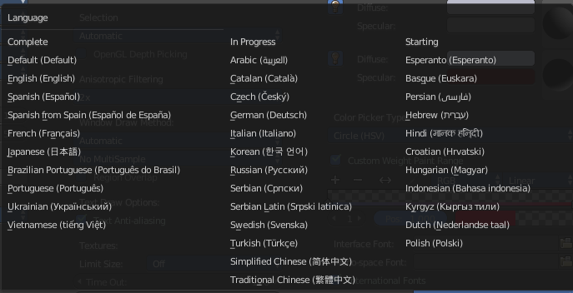
The checkbox to enable the international fonts.

Language
Here you can choose the language.

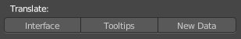
Translate
Here you can define what parts of the Ui you want to be localized.

Interface
Interface translates all the interface texts

Tooltips
Tooltips translates the tooltips too.

New Data
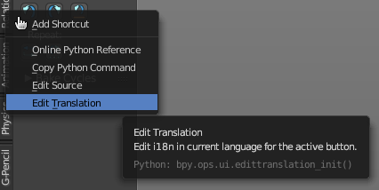
New data is meant to edit the localization texts.
This can be done in the right click menus of the tools when everything is set up in the correct way.

Note
This feature is currently not functional in Bforartists. It ends in an error message.

Let's nevertheless document the way how it should work. Note that you need a Bforartists repository for that. The binary version does not come with the editable *.po files, but with already compiled *.mo files for the translation.
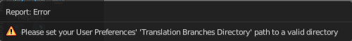
Note that you first need to set the path to the translation files for that. Or you will get an error. This is done in the File tab. The |18n string.
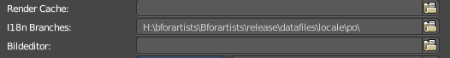
The path should lead to the *.po files that you want to translate. Which can be found in the Bforartistrs repository.
And you need to enable the Manage UI translations addon. And to fix the paths in this addon. The default paths are currently set for Blender.

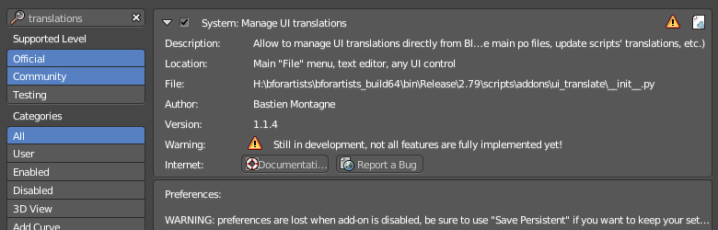

And then you might end in this error here ...
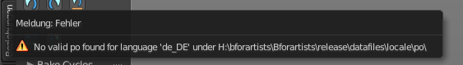

In case somebody has an idea what's going on here, every hint is welcome ...

